**WEB DEVELOPER TASK**

**HTML & CSS Design**

**TASK DETAILS:**

1. Design a resume as shown in the below image.
2. Use only HTML & CSS for the design.
3. Usage of any deprecated tags is not allowed.
4. The HTML tags open and close should be in the proper way.
5. Usage of **bootstrap** is not allowed.

**How do I complete the task?**

1. **How do I complete both designs?**

* Create a file with the extension of **.html**
* Inside the file use necessary elements for the design
* An example design attached with this document.

**2. Any specifications and constraints?**

Front-End: **HTML, CSS**

**Do’s**:- Use HTML, CSS tags.

**Don’t**:- Don't use any deprecated tags.

**Don’t**:- Bootstrap is not allowed to use.

**3. How do I submit my work?**

* + Deploy your web application in Netlify ([https://www.netlify.com](https://www.netlify.com/)).
  + Add all your work files to GitHub(<https://github.com/>).
  + Submit your urls in the portal.

**4. Any basic hints to solve?**

<https://developer.mozilla.org/en-US/docs/Web/HTML>

<https://developer.mozilla.org/en-US/docs/Web/CSS>

<https://gist.github.com/rvsp/735c2cf7cf360f797bae093fa2dfe04d#file-task-1-jpeg>

<https://html.spec.whatwg.org/multipage/>

<https://www.w3.org/Style/CSS/Overview.en.html>

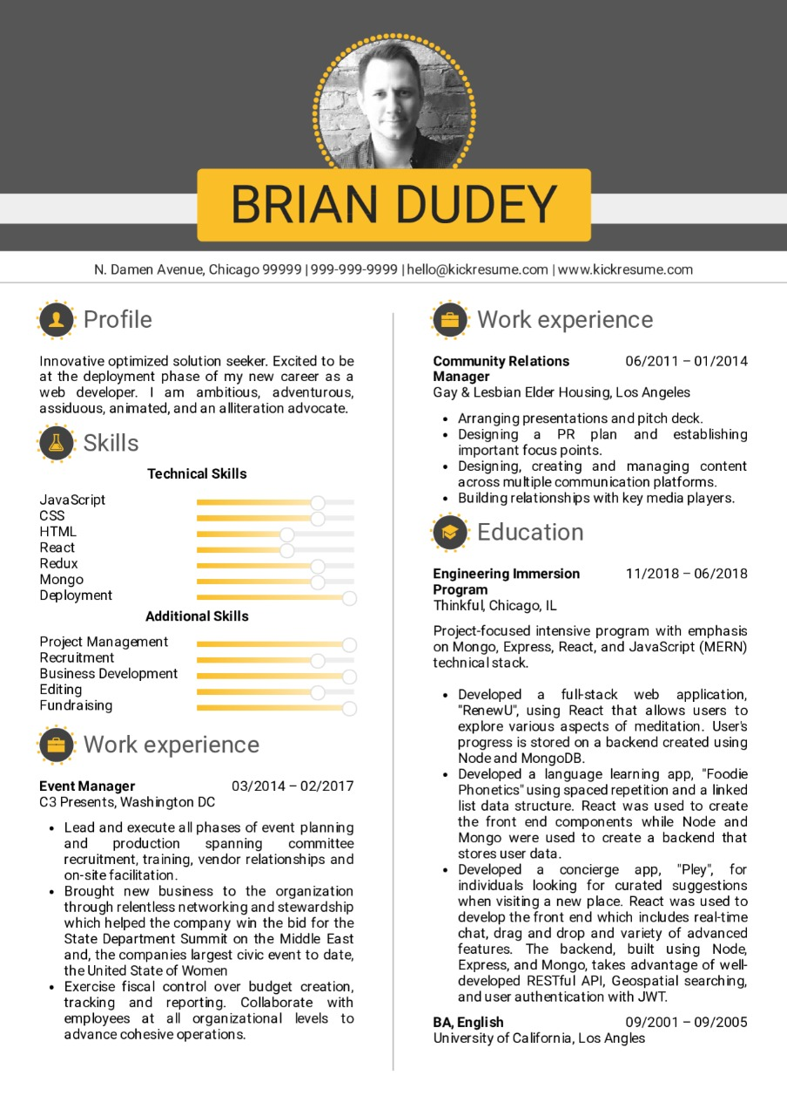

**5. Terms and Conditions?**

* You agree to not share this confidential document with anyone.
* You agree to open-source your code (it may even look good on your profile!). Do not mention our company’s name anywhere in the code.
* We will never use your source code under any circumstances for any commercial purposes; this is just a basic assessment task.

**NOTE:** Any violation of Terms and conditions is strictly prohibited. You are bound to adhere to it.